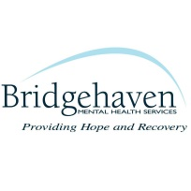
Bridgehaven Center for Peer Excellence
Adult Peer Support Specialist Training (Agency)
This Training has been approved by the Department of Behavioral Health, Developmental and Intellectual Disabilities for individuals who have the desire to become Adult Peer Support Specialists. The training is 6 hours a day for 5 days (M - F) for a total of 30 hours. The cost of the training is $350.00.
Organization Name

Street Address

City County

State Zip

Phone Email

We are sending Peers for the training starting Monday

Peers’ Names Peer’s Email

Payment: By Check (check box and mail to address below)

Bridgehaven Center for Peer Excellence
950 South First Street
Louisville KY, 40203
Attn: Molly Clouse

Or Credit Card: Please Fax form to (502) 585-9466 or e-mail to mclouse@bridgehaven.org

Name on Credit Card
Billing Address Billing Phone #

Card # CVS# (security code)

Expiration Month Year

For any questions, please contact Molly Clouse at (502) 585-9444 or mclouse@bridgehaven.org.

